**Q1. The Relational Model**

**Q1.1.**

Students ( sno, surname, givename, major )

Staff ( eno, surname, givename, department, rank )

Class ( cno, lecturer*, day, time, room )

Enrol ( sno*, cno*, grade )

**Q1.2.**

**Student**

CREATE TABLE Student

(

sno char(20) NOT NULL ,

surname char(30) ,

givename char(30) ,

major char(30) ,

PRIMARY KEY (sno)

);

**Staff**

CREATE TABLE Staff

(

eno char(20) NOT NULL ,

surname char(30) ,

givename char(30) ,

department char(30) ,

rank char(30) ,

PRIMARY KEY (eno)

);

**Class**

CREATE TABLE Class

(

cno char(20) NOT NULL ,

lecturer char(20) NOT NULL ,

day char(30) ,

time char(30) ,

room char(30) ,

PRIMARY KEY (cno) ,

FOREIGN KEY (lecturer) references Staff (eno)

);

**Enrol**

CREATE TABLE Enrol

(

sno char(20) NOT NULL ,

cno char(20) NOT NULL ,

grade char(20) ,

FOREIGN KEY (sno) references Student (sno) ,

FOREIGN KEY (cno) references Class (cno ) ,

PRIMARY KEY (sno, cno)

);

**Q.1.3.**

**Student**

INSERT INTO Student VALUES ('s1001', 'Smith', 'Tom', 'History');

INSERT INTO Student VALUES ('s1002', 'Chin', 'Ann', 'Maths');

INSERT INTO Student VALUES ('s1003', 'Lee', 'Perry', 'Arts');

INSERT INTO Student VALUES ('s1005', 'Smith', 'John', 'History');

INSERT INTO Student VALUES ('s1006', 'River', 'Jane', 'Arts');

**Staff**

INSERT INTO Staff VALUES ('e123', 'Bowl', 'Alex', 'Maths', 'Lecturer');

INSERT INTO Staff VALUES ('e205', 'Cox', 'Kevin', 'CSC', 'Associate Professor');

INSERT INTO Staff VALUES ('e301', 'Jones', 'David', 'Arts', 'Senior Lecturer');

**Class**

INSERT INTO Class VALUES ('isys155', 'e123', 'Wed', '17:30', '80.01.12');

INSERT INTO Class VALUES ('cosc121', 'e205', 'Thu', '08:30', '12.10.02');

INSERT INTO Class VALUES ('artc131', 'e301', 'Mon', '10:30', '10.08.09');

INSERT INTO Class VALUES ('cosc101', 'e205', 'Tue', '14:30', '14.09.05');

**Enrol**

INSERT INTO Enrol VALUES ('s1001', 'isys155', 'HD');

INSERT INTO Enrol VALUES ('s1003', 'cosc121', ' ');

INSERT INTO Enrol VALUES ('s1005', 'artc131', 'CR');

INSERT INTO Enrol VALUES ('s1006', 'cosc101', ' ');

**Q2. SQL**

**Q2.1.**

The query will show the field number and the title of the field table with the state of field number ranging from 500 to 599 or the title name should include the DATA word in it. The DATA word can be placed at the beginning of the title, in the middle, or at the end.

**Q2.2.**

Select paper.panum, paper.title, author.acnum, interest.fieldnum

From paper, author, interest

Where paper.panum = author.panum

AND author.acnum = interest.acnum;

**Q2.3.**

Select COUNT (acnum)

From academic

Where deptnum = 100;

**Q2.4.**

Select title

From paper

Order by title ASC;

**Q2.5.**

Select *

From field

Where title like 'Data%'

AND title NOT like 'Database%';

**Q2.6.**

Select paper.panum, paper.title, author.acnum

From paper, author

Where paper.panum = author.acnum;

**Q2.7.**

Select famname, givename

From academic, department

Where (acnum >= 200 AND acnum <= 299)

AND department.descrip='RMIT CS'

Order by famname ASC;

**Q2.8.**

Select famname, givename

From academic, department

Where academic.deptnum=department.deptnum

AND state = 'VIC'

OR state = 'Vic'

Order by famname ASC;

**Q2.9.**

Select famname, givename

From academic

Where title IS NULL

Order by famname ASC;

**Q2.10.**

Select COUNT (distinct instname)

From department;

**Q3. ER**

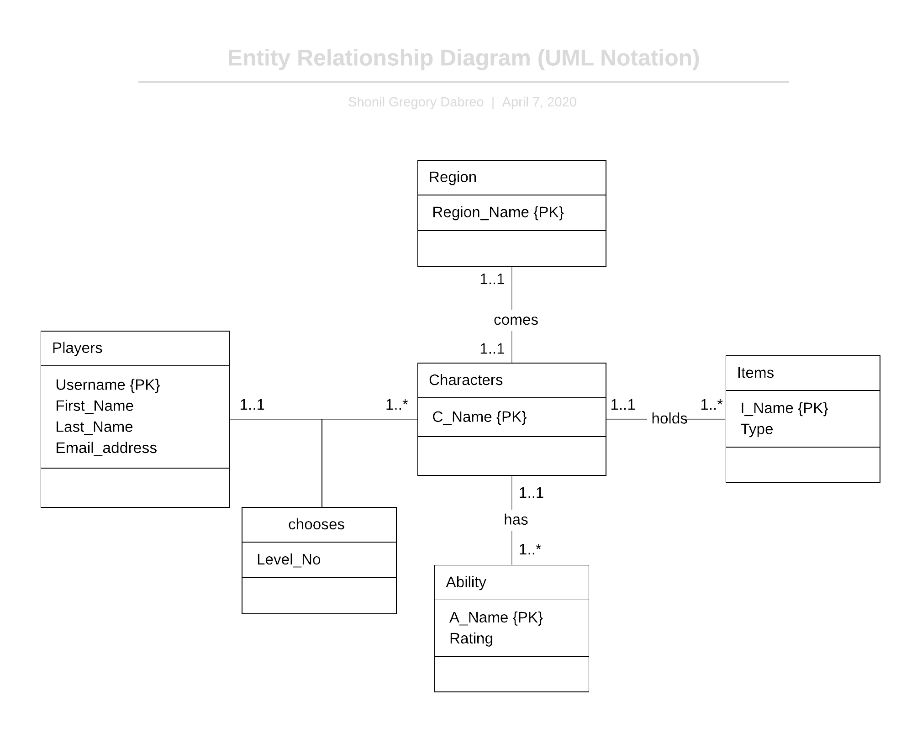

**Assumptions:**

1. Assuming that the Players class includes the information of the registered players.